International School

Database Design and Data Mapping Document
Course: System Integration Practices
Project Title: Integrated HR & Payroll Dashboard System for Company X
Case Study 2: Models Integration
Version: 1.0
Date: 22/03/2026
Group: Group 5
Semester: 2 – 2025–2026
Instructor: MSc. Nguyen Dang Quang Huy
Team Members:
Name | Student ID
Thong, Le Huu | 29219038101
Rin, Doan Ba | 29219037721
Tai, Su Phat Tai | 29211162809
Minh, Vo Van | 29219261748
Vinh, Nguyen Tran Xuan | 29211138585

Approved by
MSc Huy, Nguyen Dang Quang
Group Project - Instructor:

Name Signature Date

Da Nang 03/2026

Project Acronym | HRD
Project Title | Company X – Integrated HR & Payroll Management Dashboard
Start Date | 22 Mar 2026 | End Date | 22 Mar 2026
Lead Institution | International School, Duy Tan University
Role | Name | Email |  | Phone
Project Mentor | Nguyen Dang Quang Huy
 | Le Huu Thong | bass030196@gmail.com |  | 0768463655
 | Su Phat Tai | phattai0935@gmail.com |  | 0766657942
 | Nguyen Tran Xuan Vinh | xuanvinh2005nh@gmail.com |  | 0845015537
 | Vo Van Minh | vanminhvo2005@gmail.com |  | 0707944067
 | Doan Ba Rin | doanbarin@gmail.com |  | 0766721747

DOCUMENT NAME
Document Title | Database Design and Data Mapping
Reporting Period | 29– March - 2026
Author(s) | Le Huu Thong  Vo Van Minh  Su Phat Tai  Doan Ba Rin  Nguyen Tran Xuan Vinh
Role | Developer
Date | 22/03/2026 | File name | 6. Database Design and Data Mapping .docx

DOCUMENT APPROVALS
Document Approvals: The following signatures are required for approval of this document.

Mentor | Huy, Nguyen Dang Quang | Signature:
 |  | Date:
Team member(s) | Thong, Le Huu | Signature:
 |  | Date:
 | Tai, Su Phat | Signature:
 |  | Date:
 | Rin, Doan Ba | Signature:
 |  | Date:
 | Vinh, Nguyen Tran Xuan | Signature:
 |  | Date:
 | Minh, Vo Van | Signature:
 |  | Date:
TABLE OF CONTENTS
1. Introduction 6
1.1 Purpose 6
1.2 Scope 6
1.3 Definitions, Acronyms, and Abbreviations 6
1.4 References 7
2. System Overview 7
3. Database Description 8
3.1 HUMAN Database Schema 8
3.2 PAYROLL Database Schema 12
4. Data Mapping Specification 14
5. Integration Logic Explanation 20
6. Entity Relationship Diagram (ERD) 22
7. Summary and Future Work 22

1. Introduction

Purpose
The primary purpose of this document is to provide a detailed description of the database structures for both HUMAN_2025 (SQL Server) and PAYROLL (MySQL) systems. It serves as a technical foundation for API integration by defining how data is organized, stored, and linked between the HR and Payroll domains
Furthermore, this document specifies the data mapping rules required to ensure seamless synchronization and data integrity during system operations. It acts as a primary reference for developers to implement the middleware layer and for testers to verify data consistency across the integrated dashboard.

1.2 Scope
This document focuses specifically on the architectural and structural aspects of the database integration. The scope includes:
- Database Design: Detailed schemas, table structures, and primary/foreign key relationships for both HUMAN_2025 (SQL Server) and PAYROLL (MySQL) systems.
- Data Mapping Logic: Formal definition of field-to-field mappings and transformation rules required to synchronize data between HR and Payroll domains.
- Exclusions: This document does not address API source code implementation, detailed role-based access control (RBAC) configuration, or comprehensive security protocols.

1.3 Definitions, Acronyms, and Abbreviations
Acronym/Term | Definition
HUMAN | Human Resource Management Database (SQL Server)
PAYROLL | Payroll Management Database (MySQL)
Mapping | The formal process of linking specific data fields from the HUMAN system to their corresponding fields in the PAYROLL system.
Primary Key | A unique identifier for each record in a database table
Foreign Key | A field in one table that links to the Primary Key of another table to establish relationships.
Schema | The formal structure and organization of data within the database databases.
Data Integrity | The assurance that data remains accurate and consistent during synchronization between SQL Server and MySQL.

1.4 References
- Case Study 1 – Problem Statements: Defines the core business challenges and the need for system integration.
- Software Requirement Specification (SRS) Document: Provides the detailed functional and non-functional requirements for the Integrated HR & Payroll Dashboard System.
- API Design & Integration Document (IEEE 1016): Specificies the technical architecture and endpoint logic that utilizes this database mapping.
- IEEE Std 1016-2009: Standard for Software Design Descriptions.
- IEEE Std 830-1998: Standard for Software Requirements Specifications.
- CMU-CS445 Course Material, Duy Tan University (2025): Foundational academic resources for system integration practices.

2. System Overview
System Context and Functional Summary: Company X is currently operating two stable but disconnected enterprise systems: the HUMAN system and the PAYROLL system. Due to strict business constraints, no structural changes are allowed to either database. Therefore, this integration utilizes an external API layer to synchronize data, generate combined reports, and manage alerts without altering the legacy databases.
- HUMAN System: Running on HUMAN_2025 (SQL Server) , this system acts as the master source of truth for all Human Resources data. Its core functions include managing employee profiles, department structures, job positions, and dividend records.
- PAYROLL System: Running on payroll (MySQL) , this system is dedicated to financial processing and payroll reporting. It handles salary calculations and attendance tracking, while also storing synchronized copies of HR data (such as employees, departments, and positions) retrieved from the HUMAN system.
System | Database Type | Main Tables | Role in Integration
HUMAN | SQL Server | EMPLOYEE, DEPARTMENT, ATTENDANCE, POSITIONS, DIVIDENDS. | Master source of truth for HR data; Source system for employee synchronization.
PAYROLL | MySQL | PAYROLL, SALARY_DETAIL, DEDUCTION, ATTENDENCE, EMPLOYEES_PAYROLL, DEPARTMENTS_PAYROLL. | Destination for synchronized HR data; Processes financial and attendance records.

3. Database Description

3.1 HUMAN Database Schema
EMPLOYEES
Field Name | Data Type | Key | Description
EmployeeID | INT | PK | Unique employee identifier
FullName | NVARCHAR (100) |  | Employee name
DateOfBirth | DATE |  | Employee date of birth
Gender | NVARCHAR (10) |  | Employee gender
PhoneNumber | NVARCHAR (15) |  | Employee phone number
Email | NVARCHAR (100) |  | Employee email
HireDate | DATE |  | Start date of employment
DepartmentID | INT | FK | Department reference
PositionID | INT | FK | Position reference
Status | NVARCHAR (50) |  | Status of employee
CreatedAt | DATE |  | Employee created date
UpdatedAt | DATE |  | Employee updated date

DEPARTMENT
Field Name | Data Type | Key | Description
DepartmentID | INT | PK | Unique department identifier and reference to EMPLOYEE
DepartmentName | NVARCHAR (100) |  | Department name
CreatedAt | DATE |  | Department created date
UpdatedAt | DATE |  | Department updated date

DIVIDENDS
Field Name | Data Type | Key | Description
DividendID | INT | PK | Unique dividend identifier
EmployeeID | INT |  | Reference to EMPLOYEE
DividendAmount | DECIMAL (12,2) |  | Amount of dividends
DividendDate | DATE |  | Date of dividend
CreatedAt | DATE |  | Employee created date
UpdatedAt | DATE |  | Employee updated date

POSITIONS
Field Name | Data Type | Key | Description
PositionID | INT | PK | Unique position identifier and reference to EMPLOYEE
PositionName | NVARCHAR (100) |  | Position name
CreatedAt | DATE |  | Position created date
UpdatedAt | DATE |  | Position updated date
ACCOUNTS
Field Name | Data Type | Key | Description
AccountID | INT | PK | Primary key, auto-increment.
EmployeeID | INT | FK | Foreign key linking to EMPLOYEES table.
Username | NVARCHAR (50) | Unique | Unique login username.
PasswordHash | NVARCHAR (255) |  | Hashed password for security.
Role | NVARCHAR (20) |  | User access level (Admin, HR, Payroll, Employee).
Status | NVARCHAR (20) |  | Account status (Active, Locked, Inactive).
SYNC_LOG
Field Name | Data Type | Key | Description
LogID | INT | PK | Primary key, auto-increment.
SyncType | NVARCHAR (50) |  | Type of data synced (e.g., Sync_Employee).
Endpoint | NVARCHAR (255) |  | The API endpoint URL called.
Status | NVARCHAR (20) |  | Sync result (Success / Failed).
ErrorMessage | NVARCHAR(MAX) |  | Detailed error message if the sync failed.
CreatedAt | DATETIME |  | Timestamp of the log entry.

3.2 PAYROLL Database Schema
ATTENDANCE
Field Name | Data Type | Key | Description
AttendanceID | INT | PK | Unique attendance ID
EmployeeID | INT | FK | Employee ID reference
WorkDays | INT |  | Employee works day
AbsentDays | INT |  | Employee absent day
LeaveDays | INT |  | Employee leave day
AttendanceMonth | DATE |  | Employee attendance month
CreatedAt | DATETIME |  | Data created at
DEPARTMENT_PAYROLL
Field Name | Data Type | Key | Description
DepartmentID | INT | PK | Unique department ID
DepartmentName | VARCHAR (100) |  | Department Name
SyncedAt | DATETIME |  | Date data sync with HUMAN database
EMPLOYEES_PAYROLL
Field Name | Data Type | Key | Description
EmployeeID | INT | PK | Unique employee ID
FullName | VARCHAR (100) |  | Employee fullname
DepartmentID | INT | FK | Department ID reference
PositionID | INT | FK | Position ID reference
Status | VARCHAR (50) |  | Employee status
SyncedAt | DATETIME |  | Date data sync with HUMAN database
POSITIONS_PAYROLL
Field Name | Data Type | Key | Description
PositionID | INT | PK | Unique position ID
PositionName | VARCHAR (100) |  | Position Name
SyncedAt | DATETIME |  | Date data sync with HUMAN database
SALARIES
Field Name | Data Type | Key | Description
SalaryID | INT | PK | Unique salary ID
EmployeeID | INT | FK | Employee ID reference
SalaryMonth | DATE |  | Month of salary
BaseSalary | DECIMAL (12,2) |  | Employee base salary
Bonus | DECIMAL (12,2) |  | Employee bonus
Deductions | DECIMAL (12,2) |  | Salary deductions
NetSalary | DECIMAL (12,2) |  | Employee net salary
CreatedAt | DATETIME |  | Data created at

4. Data Mapping Specification
4.1. Manage Users & Roles
HUMAN Table | Field | PAYROLL Table | Field | Mapping Description
EMPLOYEE | EmployeeID | employees_payroll | EmployeeID | Primary key mapping
EMPLOYEE | FullName | employees_payroll | FullName | Direct value copy
EMPLOYEE | DepartmentID | employees_payroll | DepartmentID | Used for department grouping
EMPLOYEE | DateOfBirth
EMPLOYEE | Gender
EMPLOYEE | PhoneNumber
EMPLOYEE | Email
EMPLOYEE | HireDate
EMPLOYEE | PositionID | employees_payroll | PositionID
EMPLOYEE | Status | employees_payroll | Status
4.2. View Employee List

HUMAN Table | Field | PAYROLL Table | Field | Mapping Description
EMPLOYEE | EmployeeID | employees_payroll | EmployeeID | Primary key mapping
EMPLOYEE | FullName | employees_payroll | FullName | Direct value copy
4.3. Add New Employee

HUMAN Table | Field | PAYROLL Table | Field | Mapping Description
EMPLOYEE | EmployeeID | employees_payroll | EmployeeID | Primary key mapping
EMPLOYEE | FullName | employees_payroll | FullName | Direct value copy
EMPLOYEE | DepartmentID | employees_payroll | DepartmentID | Used for department grouping
EMPLOYEE | DateOfBirth
EMPLOYEE | Gender
EMPLOYEE | PhoneNumber
EMPLOYEE | Email
EMPLOYEE | HireDate
EMPLOYEE | PositionID | employees_payroll | PositionID
EMPLOYEE | Status | employees_payroll | Status
4.4. Update Employee Information

HUMAN Table | Field | PAYROLL Table | Field | Mapping Description
EMPLOYEE | EmployeeID | employees_payroll | EmployeeID | Primary key mapping
EMPLOYEE | FullName | employees_payroll | FullName | Direct value copy
EMPLOYEE | DepartmentID | employees_payroll | DepartmentID | Used for department grouping
EMPLOYEE | DateOfBirth
EMPLOYEE | Gender
EMPLOYEE | PhoneNumber
EMPLOYEE | Email
EMPLOYEE | HireDate
EMPLOYEE | PositionID | employees_payroll | PositionID
EMPLOYEE | Status | employees_payroll | Status
4.5. Delete employee

HUMAN Table | Field | PAYROLL Table | Field | Mapping Description
EMPLOYEE | EmployeeID | employees_payroll | EmployeeID | Primary key mapping
4.6. Manage Departments

HUMAN Table | Field | PAYROLL Table | Field | Mapping Description
Departments | DepartmentID | departments_payroll | DepartmentID | Primary key mapping
Departments | DepartmentName | departments_payroll | DepartmentName

4.7. Manage Positions
HUMAN Table | Field | PAYROLL Table | Field | Mapping Description
Positions | PositionID | positions_payroll | PositionID | Primary key mapping
Positions | PositionName | positions_payroll | PositionName
4.8. View Salary List

HUMAN Table | Field | PAYROLL Table | Field | Mapping Description
 |  | salaries | SalaryID | Primary key mapping
 |  | salaries | EmployeeID
 |  | salaries | SalaryMonth
 |  | salaries | BaseSalary
 |  | salaries | Bonus
 |  | salaries | Deductions
 |  | salaries | NetSalary
4.9. View Salary History

HUMAN Table | Field | PAYROLL Table | Field | Mapping Description
 |  | salaries | SalaryID | Primary key mapping
 |  | salaries | EmployeeID
 |  | salaries | SalaryMonth
 |  | salaries | BaseSalary
 |  | salaries | Bonus
 |  | salaries | Deductions
 |  | salaries | NetSalary
4.10. View Attendance Data

HUMAN Table | Field | PAYROLL Table | Field | Mapping Description
attendance | AttendanceID |  |  | Primary key mapping
attendance | EmployeeID
attendance | WorkDays
attendance | AbsentDays
attendance | LeaveDays
attendance | AttendanceMonth

5. Integration Logic Explanation
The integration logic relies on the predefined data mapping specifications to ensure seamless and accurate data exchange between the HUMAN (SQL Server) and PAYROLL (MySQL) databases. When an HR administrator creates or updates a record (such as an Employee or Department) in the HUMAN database, the API Integration Layer intercepts this event. The middleware then acts as a translator, mapping the source fields (e.g., EmployeeID, FullName) to their corresponding destination fields (e.g., Emp_Code, Emp_Name) as defined in the mapping matrix, while simultaneously handling necessary data type conversions.
Once the data payload is correctly transformed, the API pushes the standardized JSON request to the PAYROLL database to maintain system consistency. This unidirectional master-data sync (HUMAN $\rightarrow$ PAYROLL) guarantees that the payroll calculation engine always utilizes the most up-to-date organizational structure and personnel records. Conversely, financial and timekeeping records (Salaries, Attendance) are mapped and synchronized from PAYROLL back to the Dashboard or HUMAN system for comprehensive reporting.
To safeguard data integrity, the integration logic incorporates a strict error handling and rollback mechanism. If the API encounters a failure during synchronization—such as a database connection timeout or a duplicate constraint violation—it immediately logs the error details into the SYNC_LOG table. The API then triggers a rollback transaction, reverting any partial updates to prevent data mismatch, ensuring that a record is never successfully saved in only one of the two databases.
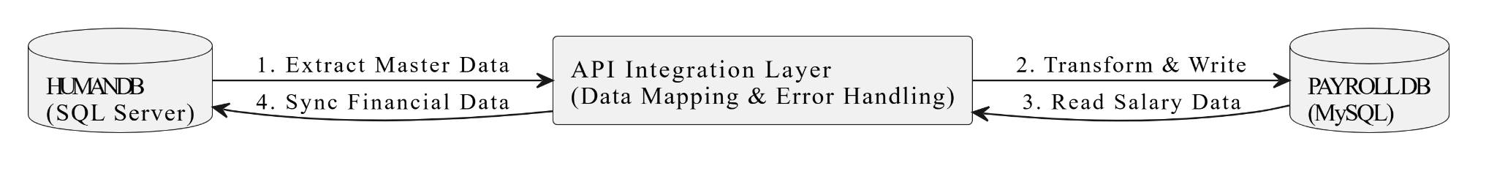

6. Entity Relationship Diagram (ERD)
- 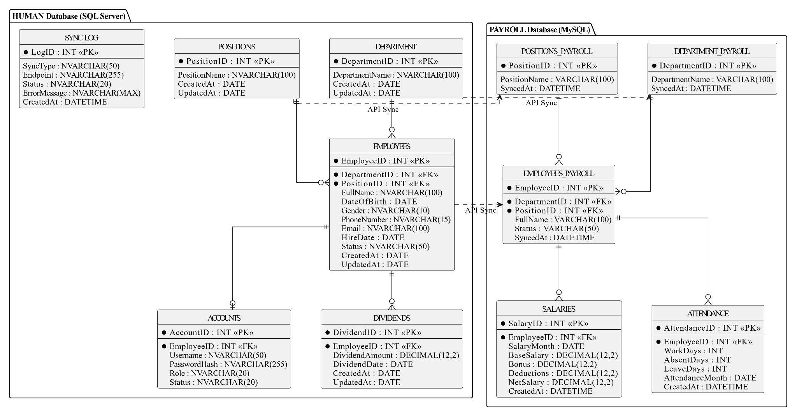

7. Summary and Future Work
This document defines the structure and mapping logic used for RESTful API integration. Establishing a clear and accurate data mapping between the HUMAN_2025 (SQL Server) and PAYROLL (MySQL) databases is crucial, as it ensures that the intermediary API layer can seamlessly translate, validate, and synchronize records without requiring any structural changes to the existing legacy systems. By completing this comprehensive mapping phase, we have laid a solid foundation for Case Study 3. In the next phase, these mapped fields and relationships will be directly implemented into the backend code (using C# or Python) to develop fully functional RESTful APIs, execute atomic cross-database transactions, and build the automated bidirectional synchronization logic.

